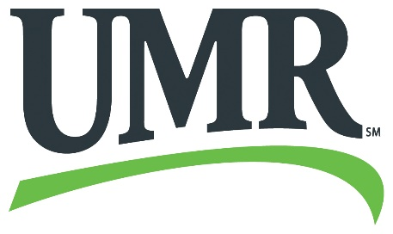

Wrap Plan Claim Form
(do not use this form if not on Wrap plan)
Name: _____________________
Member ID: _________________ Group number: ________________
Phone: ____________________ Email: _______________________
Explanation of benefits from primary insurance carrier attached? _____
Pay employee or provider? _____________________
Date of Service: | Provider Name: | Type of Service: | Amount Requested:
 |  |  | $
 |  |  | $
 |  |  | $
 |  |  | $
 |  | Total Reimbursement Requested:

Member’s signature Date
You may submit your claim to UMR by one of the following methods – include completed claim form and supporting documents:
FAX:  855-405-2189 | Mail:  UMR  PO Box 8033  Wausau WI 54402-8033 | Email:  UMR-claimSubmission@umr.com

